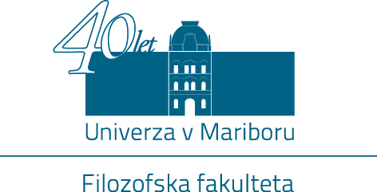

Oddelek za pedagogiko Filozofske fakultete Univerze v Mariboru v sodelovanju z Univerzitetno knjižnico Maribor, Avstrijskim kulturnim forumom Ljubljana in Slovenskim društvom pedagogov organizira

mednarodni znanstveni simpozij
Študij pedagogike med tradicijo in izzivi prihodnosti v centralni in jugovzhodni Evropi

v Mariboru od 22. do 24. oktobra 2015

The Department of Pedagogy, Faculty of Arts, University of Maribor, University of Maribor Library,
Austrian Cultural Forum Ljubljana and the Slovenian Pedagogical Association are organizing an

international symposium
Between Tradition and Future Challenges: The Study of Pedagogy in Central and South-East Europe

in Maribor from 22nd to 24th October 2015

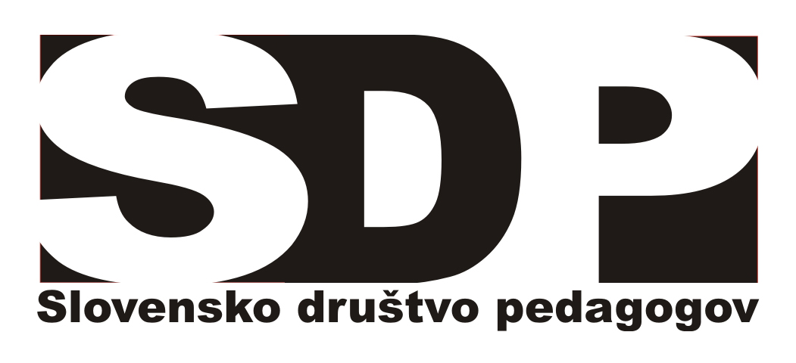 | 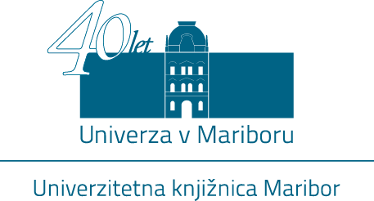 | 

INTERNATIONAL CONFERENCE
MARIBOR, 22. – 24. October 2015

Between Tradition and Future Challenges: The Study of Pedagogy in Central and South-East Europe
CONFERENCE PROGRAM

THURSDAY, October 22 (location – UNIVERSITY OF MARIBOR LIBRARY )
16:00 – 16:30 | Registration

16:30–17:00 • OPENING CEREMONY
17:00–18:00 | Keynote presentation  Wolfgang Brezinka: Das Fach Pädagogik an österreichischen Universitäten und die Ausbildung der Lehrer 1805-1918
19:00 | Welcome to MARIBOR – reception hosted by the mayor of Maribor  City Hall

FRIDAY, October 23 (location – UNIVERSITY OF MARIBOR LIBRARY)
9:00–10.30
Chair: Tadej VIDMAR

- András NEMÉTH: Developmental phases of educational sciences as academic discipline in Hungary
- Simonetta POLENGHI: Development of academic Pedagogy in Italy - A sketch from 19th century to todays' situation
- Blanka KUDLÁČOVÁ: Pedagogy as Part of University Education in Slovakia - Historical and Contemporary Perspective

10:45–12:15
Chair: Simonetta POLENGHI

- Albena CHAVDAROVA: Pedagogy as degree program in Bulgaria - historical and contemporary aspects
- Tomáš KASPER, Dana KASPEROVA: Development of Pedagogy in the Czech lands of the Austro-Hungarian Monarchy and in Inter-war Czechoslovakia (comparison of Czech and German pedagogical discussion)
- Tadej VIDMAR: Pedagogy at the University of Ljubljana before, during, and after World War II

12.15–14:00 | Lunch

FRIDAY, October 23 (location – UNIVERSITY OF MARIBOR LIBRARY)
14:00–15:30
Chair: Suzana MIOVSKA SPASEVA

- Sofija VRCELJ, Siniša KUŠIĆ : In search of identity of pedagogy (studies) – from the perspective of the Bologna Process in Croatia
- Mariyana ILIEVA: Mikhail Geraskov (1874-1957) – The Originator of University Pedagogy in Bulgaria
- Mirko LUKAŠ: Ideas of goodness and philanthropy have strengthened the autonomy of the special science of nurturing on the Croatian territory

15:45–17:15
Chair: Siniša KUŠIĆ

- Katarina TIBAUT, Milena IVANUŠ GRMEK: The workload of students of Faculty of Arts University of Maribor after the Bologna reform – analysis of curriculum
- Rotraud CORIAND: General didactics between traditional faculty culture and digital teaching in academic mass education
- Marko PALEKČIĆ, Florian H. MÜLLER: Autonomous learning motivation before and after the Bologna Process - Perspectives on self-determination theory
17:30–19:00
Chair: Sofija VRCELJ

- Irena LESAR: The inclusive education study programme: Is it (or should it be) the successor of special or general pedagogy?
- Zvonimir KOMAR: Pedagogical character of University
- Johanna HOPFNER: Impressions on Shaping Pedagogy by Reforming Study Courses

20:00 | Dinner and social evening in Hotel 365

SATURDAY, October 24 (location – FACULTY OF ARTS)
9:00–10.30
Chair: Vučina ZORIĆ

- Edvard PROTNER: Comparison of Development of the Study of Pedagogy in Austria and Slovenia
- Štefka BATINIĆ; Igor RADEKA: Development and Prospects of Pedagogy in Croatia
- Nataša VUJISIĆ ŽIVKOVIĆ, Vera SPASENOVIĆ: Development of Pedagogy as a Scientific and Academic Discipline in Serbia Perceived through the Relationship between Professional and Scientific Field

10.40–12.40
Chair: Igor RADEKA

- Snježana ŠUŠNJARA: Bosnian-Herzegovian pedagogy between the past and future: How to respond to the today’s challenges?
- Vučina ZORIĆ: Beginnings, functioning and developmental perspectives of the Department of pedagogy in Montenegro
- Suzana MIOVSKA SPASEVA: The study of pedagogy in Macedonia: origins, development and contemporary challenges

13:00-14:00 Meeting of CEEPUS network partners
14.00–15:00 | Lunch

